Importing Clients in Connexx 9

After the email with the settings are received from the customer, save the settings to a file on your desktop that is used for these files.
- Go to File>Client Database Import/Export

- Click the tab for “Import Client Data”

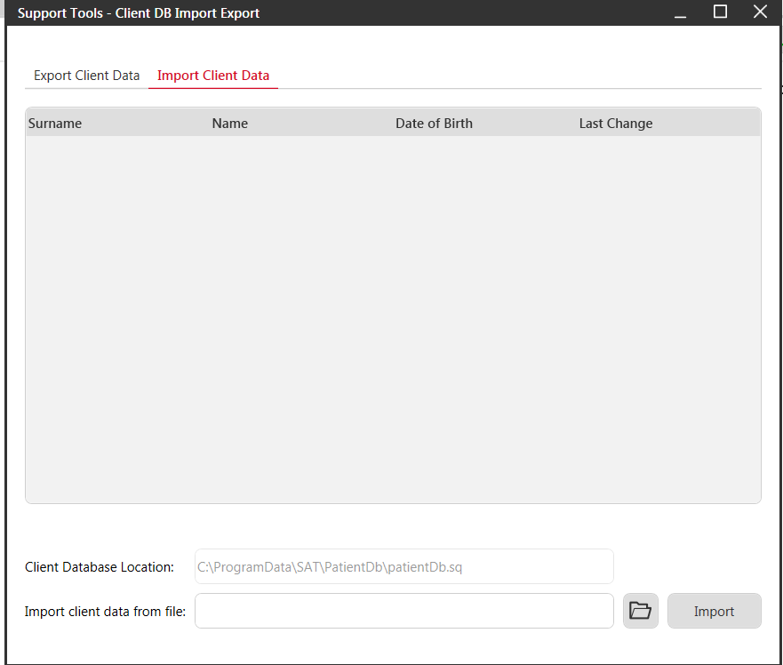

- Go to “Import client data from file” and click the folder to browse to the location where you saved the file:
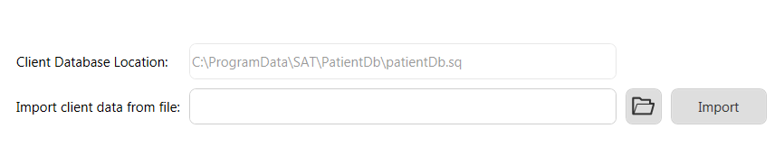
- Find your saved exported file (Mine is called Export.nha) in this case and I saved it to my desktop)
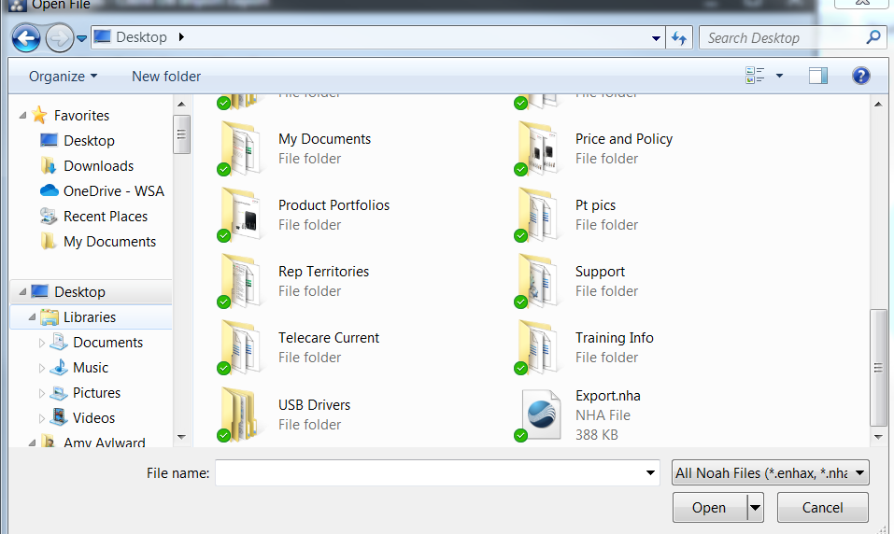

- Double click the file and it will show up in the “Support Tools-Client DB Import Export window
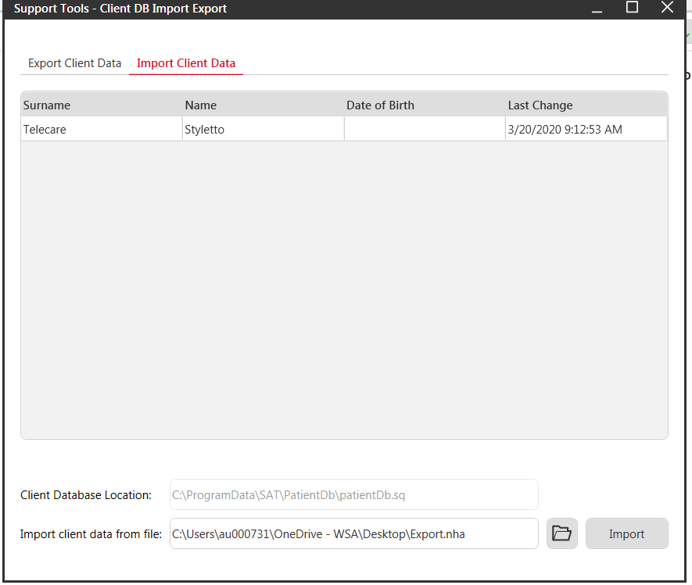

- Click Import
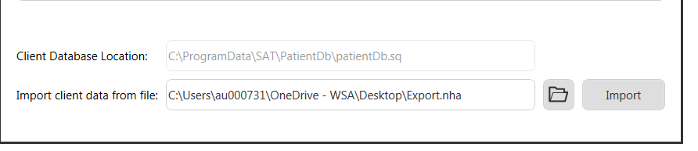

- Get a confirmation of the import (if it’s a duplicate record, you will see options for what to do with it)
